What we got up to
OOOOOOOH Saturday Nights, sorted.
A match made in heaven with iconic Ant & Dec Saturday Night Takeaway to launch NPD within the iconic McDonnells brand.
G’wan Giz a Squeeze
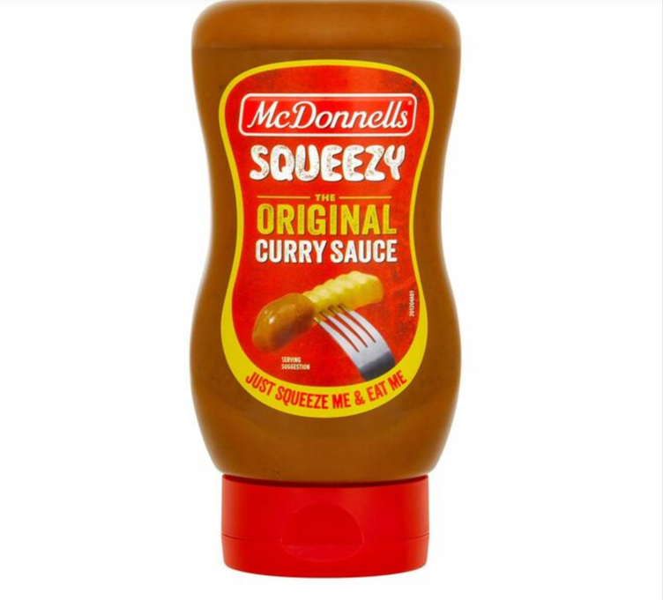
Without fail, every Saturday night we’re treating the nation to all sorts of mouth-watering fakeaway favourites.
Everything from a fully loaded chicken fillet roll (drenched in curry sauce of course) to curry sausage rolls.
McDonnells Irelands favourite curry sauce* recent partnership with Ant & Dec’s Saturday Night Takeaway was a match made in heaven!
Ant & Dec Saturday Night Takeaway is a firm family favourite which runs every Saturday every for a 7-week period, now in its 20th year the series has an estimated 1.6 million viewers tuning in live & VOD across the series. Ant & Dec’s Saturday Night TakeAway has an immensely loyal viewer so by building an association with this viewer helps drive McDonnells preference & brand stature amongst our target consumer. In 2022, we decided to renew our headline sponsorship based on incredibly strong viewership figures in 2021 and the series was ranked 10th in the top 20 programs for 15-44 in February, a month dominated by Six Nations Rugby.
In our second year as the Irish headline sponsor we were delighted to use the opportunity to launch our newest product to market, our McDonnells Squeezy The Original Curry Sauce. By adopting a full 360 campaign approach across areas like
- ATL TV advertising across all key channels, prime time slots
- Ambassador programme
- Influencer Outreach programme
- Traditional media drop
- In store POS / theatre
What a cracking campaign looks like:
- Coverage for Press & influencer kit- 70%
- Ambassador Engagement 1.5%
- McDonnells Owned Assets Engagement: 1%
- Large scale awareness of NPD
- Full distribution of NPD in major stores across the nation

Surely you know about McDonnells by now..
McDonnells has a broad consumer base, everyone from the 20-year-old male student to the mid- 50-year-old housewife and other cohorts in between. Our wide range of products are the perfect Saturday night takeaway alternative.
McDonnells is Ireland’s favourite Curry Sauce and has been making food taste great for over 30 years. The secret recipe for McDonnells Original Curry Sauce was developed especially for the Irish palate, using an eclectic range of spices sourced from around the world. No wonder it’s a firm family favourite and always included in the weekly shop!
McDonnells is an iconic Irish brand and has introduced millions of Irish people to the joys of curry. McDonnells have been bringing curry to the Irish people since the 1980’s, when Irish people think curry what they’re really thinking of is McDonnells curry sauce, Our delicious range has expanded over the years to include a number of tub flavours including Original, Mild, Hot, Slimmers, Chinese, Katsu and Gluten Free variants meaning you can have the prefect weekend curry made fresh from your own kitchen. Our range also includes the iconic Spice Bag Fake Away sachet range, which comes in Classic and Chinese Curry flavours. Spice bags are the ultimate weekend takeaway option so our McDonnells offering with our distinctive and much loved spices & flavour blend means no matter what you feel like McDonnells has your weekend Fake Away covered.
Looking for some extra curry sauce to really take your meal from bland to taste explosion? Well for those looking for a ‘curry in a hurry’ during a quick ad break, our Microwavable Original Curry Dip Pots offer the perfect solution making McDonnells Curry Sauce ready to enjoy in just 1 minute!
And finally, we also have a delicious range of take-away inspired noodles, so when the ad break comes round all you have to do is jump up, stick the kettle on & pour! Our Take-Away Noodles come in three delicious flavours – The Original Curry Sauce, Japanese Style Katsu Curry and Salt & Pepper Chicken. Just Pot. Kettle. Snack!
We got cracking
To celebrate the 2nd year of our sponsorship of Ant & Dec’s Saturday Night TakeAway we couldn’t think of a better way than to launch our new delicious tabletop, ready to eat squeezy curry sauce. Now members of the Irish public can enjoy their favourite curry sauce anytime, anywhere. Now you’re always just one squeeze away from curry perfection meaning no matter what your favourite ad break snack is you can now add Ireland’s favourite curry sauce to it with just a quick squeeze. The new McDonnells Squeezy Original Curry Sauce bottle contains 350g of pure curry heaven. Squeeze the ready to rock sauce over chips, jazz up a chicken fillet roll, turn wedges into something special or give a sausage sambo exactly what it's been missing and better again the new squeezy sauce is vegetarian friendly. The perfect accompaniment to your Saturday night in front of the TV.
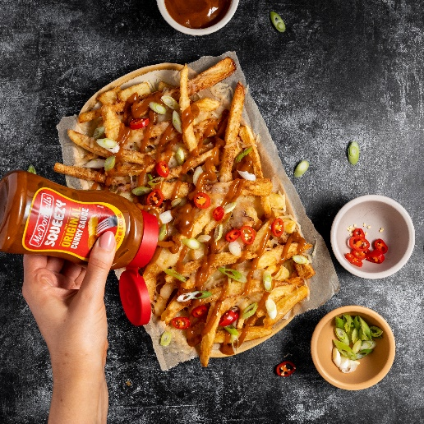
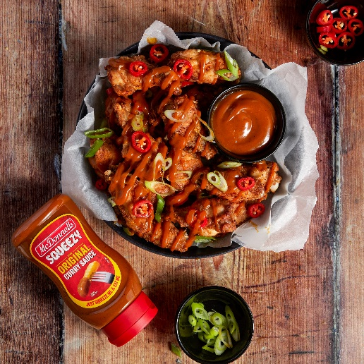
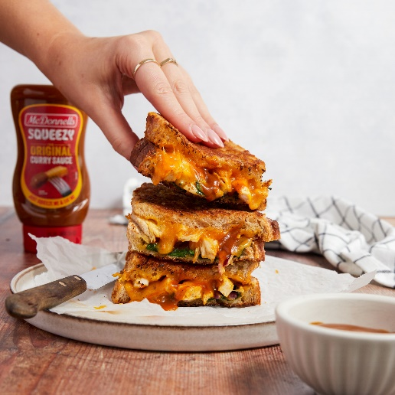
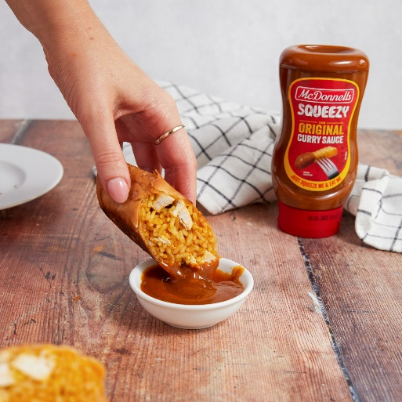

Using Irish fan favourites to spread the news!
To amplify our sponsorship of Ant & Dec’s Saturday Night Take Away and to announce our new squeezy sauce we took a 360 view in a typically McDonnells way. To drive huge awareness and talkability, we kicked off with a largescale PR drive in the form of a press drop distributed all around the country to well known celebrities, influencers & media, packed full of our new squeezy curry sauce asking recipients to ‘Giz a squeeze’ and show us all the ways they can now use our new sauce. This tongue -in-cheek and typically Irish phrase reinforces our position as an Irish brand that consumers can connect with. Each pack contained lots of bottles of product to enjoy as well as a post card, press release & branded tote bag all branded with the ‘Giz a Squeeze’ message.
Using friends of the brand
For McDonnells the use of brand ambassadors is an important part of our brand strategy, we are all about great tasting food but down to earth tone of voice with a touch of Irish humour. As such our brand ambassadors must represent this also, we work closely with Conor Ryan, The Daly Dish & Daniel Lambert. Each created a kick off recipe to showcase our squeezy curry with a delicious recipe perfect for Saturday Nights in with Ant & Dec. It was important for us to add something special to the launch and to really drive our awareness with a huge audience, as such we partnered with Rory Stories to help bring our NPD to life! The brief to each of our ambassadors was incredibly important, to create the ultimate Saturday night takeaway alternative or prefect ad break snack showcasing the McDonnells Range but in a typically McDonnells way. We were delighted to see a wide range of content coming through, everything from Crisp sandwiches with curry sauce, a spice bag burger, salt & chilli wedges with the all-important curry sauce, all recipes really embracing the brief to deliver mouth watering content that is easy to recreate at home.
Creating mouth-watering content
We partnered with up-and-coming content creators to create the perfect Saturday night fake away meals to be seeded out across our channels for the duration of the series. Our Saturday night fake away inspiration included recipes such as mouth-watering loaded chips, buttermilk chicken curry burgers with lashings of squeezy curry sauce & curry sausage rolls incorporating both static, reel & short form video formats to tap into viewer trends and format preferences across our key social media channels (TikTok, Instagram & Facebook). Each piece of content has a dedicated social media promotion budget to ensure we are reaching as may accounts as possible to maximise our partnership and to own the Saturday night food space in family homes around Ireland.
Uniquely McDonnells Social Media
As with most brands, social media plays a hugely important role for McDonnells. We activated our sponsorship across all our channels TikTok (reaching a younger audience), Instagram & Facebook. We created short cut downs of our TV ad with relevant captions focusing on our Ant & Dec partnership to engage our growing audience. Content included memes & short form video content with relevant captions both to our audience and in keeping with current trends promoting our audience to interact with our content.
Each week we showcased a number of Ant & dec specific pieces of content including a reminder to tune in each Thursday, live story content, recipe inspiration & a prompt to tune in next week for the next instalment. Our live story content encourages engagement by use of polls, question boxes & graphics with movement for the viewer to interact with. We were able to play up divisive food opinions such as ‘Are you a sauce all over or sauce on the side’. Live weekly content also plays up iconic Ant & Dec Saturday Night TakeAway moments such as ‘Win the Ads’. Our live content heavily focused on the products in our range that can be made in only a couple of minutes during the ad break, such as our new Squeezy sauce, Red instant noodle pots & curry dipping pots.

We smashed our targets
The power of our sponsorship of Ant & Dec Saturday Night Take Away enabled us to list our NPD out of cycle with all retailers taking products earlier than originally committed. Over 1.6million people viewed our sponsorship stings across the sponsorship.
We received widespread coverage of our PR activities across numerous channels creating huge awareness and talkability. Excellent coverage across media publications such as The Irish Sun; The Irish examiner; Shelf Life; Her.ie to name a few with a combined reach of 640,000.
Influencer coverage came from a diverse pool of individuals across foodies, comics, lifestyle, media & tiktok stars with a combined reach of 770,000. Combined coverage across media & influencers was 70.3% of those who received the drop exceeding our target
Our ambassadors threw their weight behind the campaign by creating some fantastic content for us with everything from a comedy sketch to delicious recipes with an overall reach of 1.1million with an average engagement rate of 4.71%
McDonnells owned content seeded out across our social channels generated a fantastic response exceeding our target and achieving 1.64% engagement.
Conclusion
As Ireland’s favourite curry sauce*, McDonnells needs to ensure we remain relevant to our target audience to cement our place & future proof against our competitors, by sponsoring headline shows such as Ant & Dec’s Saturday Night TakeAway this allows McDonnells to remind consumers why they love our products so much. By adopting a 360 approach to our sponsorship allowed us to reach consumers multiple times across various different channels & media outlets.
*Kantar 2021

